**Topic:** Euclid, Book I and the Proof of the Pythagorean Theorem

**Notes on Topic:** After Alexandria was established (332BC) at the mouth of the Nile River, by Alexander the Great, the city grew rapidly.   
One institution formed was the great Alexandrian library, supplanting the academy for the world’s foremost center of scholarship, at one point the facility had over 600,000 papyrus rolls.  
Alexandria would remain the intellectual focus of the Mediterranean world through the Greek and Roman periods until its final destruction in 641.  
  
Around 300BC, among many scholars attracted to Alexandria, was a man named Euclid, who went to set up a school of mathematics.   
  
Euclid is known as one of the greatest mathematicians in history and has influenced every subsequent Greek mathematician.   
He is most known for writing the Elements. This book of mathematics has been contemplated and analyzed and edited for centuries upon centuries up through modern times.   
It has been said that besides the Bible, the Elements has received the most intense scrutiny of all books from Western Civilization.   
Elements is divided up into 13 books with 465 propositions regarding plane and solid geometry and number theory.   
It is decided today that few of the theorems were of Euclid’s own discovery, but rather from the known body of Greek mathematician.   
To refer to a specific proposition one would say, II.31, meaning the second book, 31st proposition. The parallel is accurate, as above all other books, this would be the one referred to as “the bible of mathematics”   
Over 2000 editions of the Elements have been released   
After the fall of Rome, Arab scholars carried it off to Baghdad and it reappeared in Europe during the Renaissance, its impact was profound   
“At night… he read Euclid by the light of a candle after others had dropped off to sleep” from Carl Sandburg about Abraham Lincoln  
“At the age eleven, I began Euclid, with my brother as tutor. This was one of the great events of my life, as dazzling as first love,” Bertrand Russell in his autobiography  
“The propositions we shall examine were studied by Archimedes and Cicero, by Newton and Leibniz, by Napoleon and Lincoln. It is a bit daunting to place oneself in this long, long line of students,” JTG 31.  
  
Euclid’s idea was not so much as to present new mathematics, but re-examine old mathematics in a clear, organized and logical fashion.  
Euclid gave a critical axiomatic development of his subject, this is a critical distinction  
He began with 23 definition, 5 postulates, and 5 common notions or general axioms.  
These were used to begin to develop the proofs of the propositions, after proving the first proposition, he could use this to prove the second, and so on.  
Euclid used almost a flowchart like system, each proof could be traced back to its axiomatic reasoning  
“His obvious success of weaving the pieces of his mathematics into a continuous fabric from the basic assumptions to the most sophisticated conclusions served as a model for all subsequent mathematical work,” JTG 32.  
  
Book I: Preliminaries:

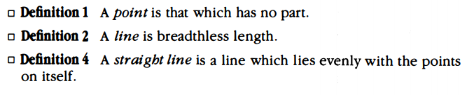

There are some criticism, since there are some murky terms used in the definitions like “evenly with the points of itself” and “breadthless”  
Nevertheless in modern mathematics, there are still terms that are left undefined, such as “point”, a logical system must start with a few undefined terms to avoid “circular jumble”

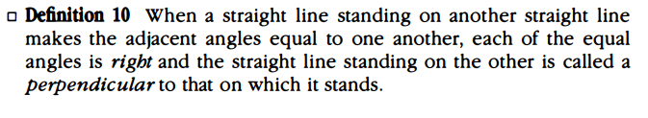  
Nowhere in the Elements is the notion of a “degree” ever mentioned. The only angle measure he ever refers to is right angles “one of two equal, adjacent angles on a straight line”

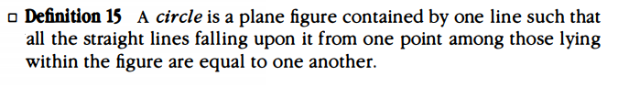

“Straight lines” meaning the radii   
Definition 19-22: triangle (plane figures contained by three straight lines), quadrilateral (contained by four), equilateral (contained by three equal lines), isosceles (those with “two of its sides alone equal”)

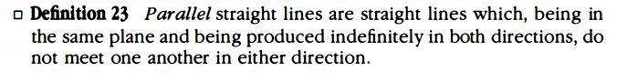

Definition 23, the final definition turned out to be of great importance. Euclid never used the term equidistant or referred to the slopes, he simply said, parallel lines will never intersect  
  
He then continued to give the five postulates for his geometry, were meant to be “self-evident truths” of the system

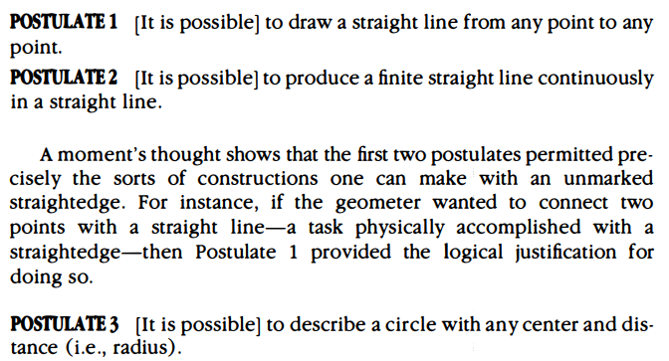

All of these postulates are almost giving permission to one seeking to draw these figures with a straightedge and compass, Euclid is saying, if you seek to draw these, it can be done  
Euclid did not include the classic technique of “Transferring lengths” as a postulate, this bothered some people, for using a compass to transfer the lengths of a given line was the only way that geometers knew how to do so, but Euclid here is not giving permission to do so, some refer to Euclid’s compass as “collapsable” meaning, if one picks it up from the plane, it will collapse, leaving all information on the plane  
Instead he figured out another method to transfer lengths, and proves it in his third proposition, “it is to Euclid’s credit that he avoided assuming what he could in fact derive”

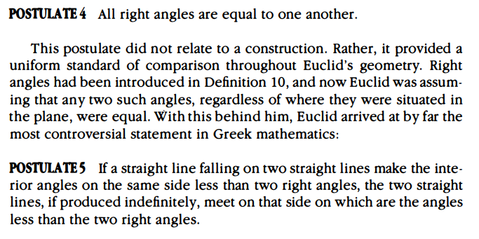

Postulate 4 sets a uniform standard for right angles, he already defined them in Def 10, but here he is setting it up so we know that no matter where right angles are on the plane, they are always equal to one another  
Postulate 5 gets a lot of heat. Euclid wanted to “avoid assuming” and keep his postulates to a minimum, yet this postulate does not seem to be evidently true. If fact, it requires a diagram to fully understand.  
Many people refer to this as Euclid’s parallel postulate, but in fact this is the opposite, the nonparallel postulate, since it is giving conditions in which two lines meet  
There is evidence that Euclid was uncomfortable using this as a postulate himself, since he does not refer to it once in his first 28 propositions, he could have easily made this into a proposition and proved it with fairly elementary algebra  
  
Then he gives his five common notions which were not necessarily geometric, but more general nature, that also were meant to be self-evident

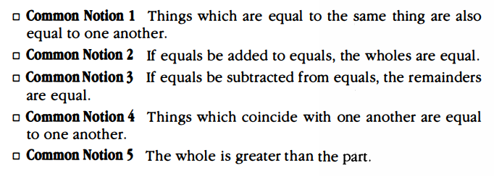

Common notion 4 raised some eyebrows, this is meant to say if you were to pick up a plane figure and move it and place it on top of another figure and they coincide in all aspects, angles, sides, measures, then they are equal. Some felt, this had more of a geometric nature and belonged with the postulates  
  
Book I: Early Propositions:

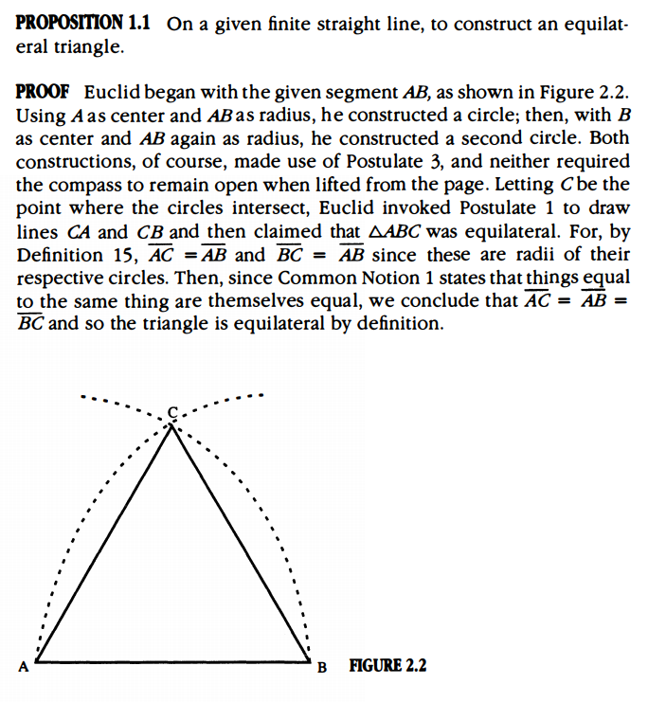

Notes on proof: People were distraught at the proof since Euclid assumed that point C in fact exists and the two circles intersect at all, for it was not a postulate that the two circle must meet  
The only reason they must meet is that they do so in the diagram shown, but Euclid wanted to justify all his propositions without the use of pictures, he wanted to rely on logic  
When relying on visual representation, things like “the triangle looks equilateral” become justification enough  
There is argument that the need of a “postulate of continuity” could be used to claim that the circles meet, there are some other gaps in Euclid’s arguments throughout the Elements  
Euclid allowed himself to use diagrams instead of clear logic, what is called the sin of omission  
There are some missing postulates, and some gaps in logic here and there, but none of the 465 theorems in the Elements is false, with some minor modifications and addition of postulates, the Elements have withstood the test of time  
If you look at the ancient astronomers or chemists or physicists, no one in modern times would rely on their texts to explain modern phenomena, yet Euclid’s text stands true, as it only depends on the “keenness of reason”  
Prop 1.2, 1.3 established the ability to transfer a length  
Prop 1.4 is the first of the congruence schemes, today we refer to this as the Side-Angle-Side theorem  
Prop 1.5 states that the base angles of an isosceles triangle are equal. This theorem is referred to as the “bridge of fools” partly because Euclid’s diagram looked like a bridge and partly because the weaker geometers could not understand the logic and thus could not cross into the rest of the Elements   
Prop 1.6 is the converse of 1.5, Euclid loved to insert the proof of the converse immediately after the theorem even if it interrupted the flow of logic  
Prop 1.8: SSS  
Prop 1.9, 1.10, 1.11, 1.12: bisect a given angle, bisect a segment with a straightedge and compass, construct a perpendicular to a point on a line, or construct a perpendicular to a point not on the line  
Prop 1.13: defining what adjacent angles are if there is a straight line, then the two angles “sum to two right angles”  
Prop 1.14: the converse of 1.13, if two angles sum to two right angles, then they form a straight line

Proposition I.15, I.16  
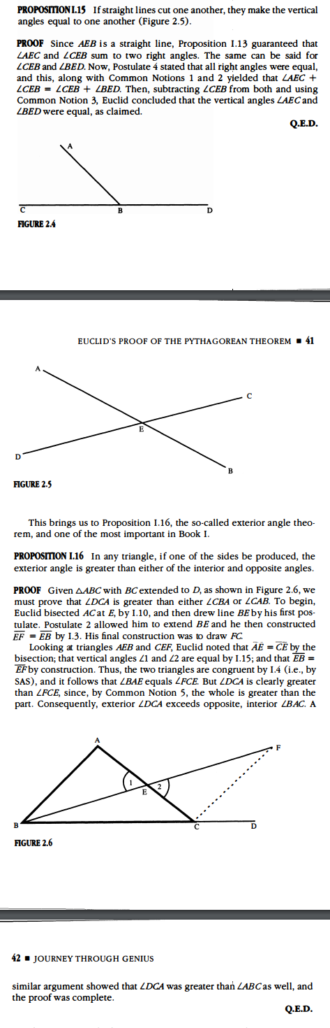

Prop 1.20: the sum of two sides of a triangle is strictly greater than the third alone, seems self-evident, but again Euclid did not want to assume even the most obvious  
Prop 1.26: The last of the congruence theorems; first part is ASA as a consequence of SAS, second part, AAS, **insert proof here**

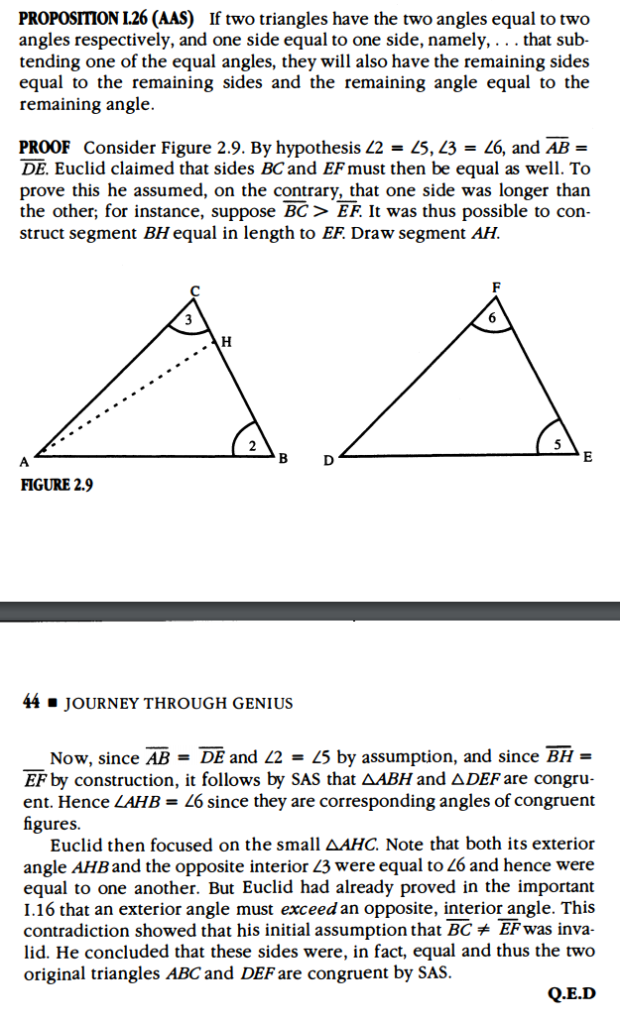  
  
Book I: Parallelism and Related Topics:  
After all of these propositions, we are reaching the end of book 1, Prop 1.46 is how to construct a square given a line segment, which was reliant on parallel lines  
He then saves the Pythagorean Theorem for the end of the first Book

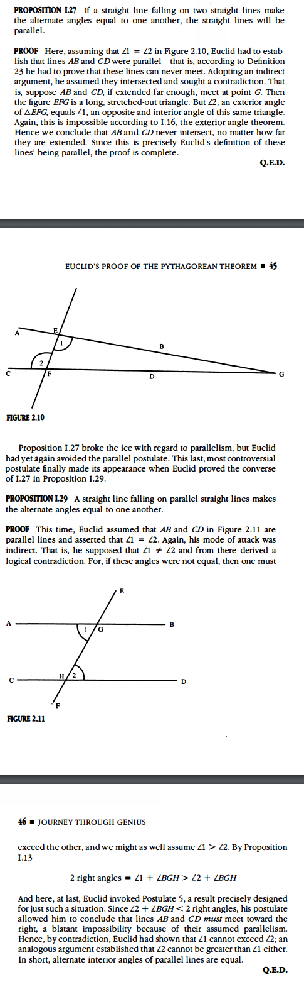

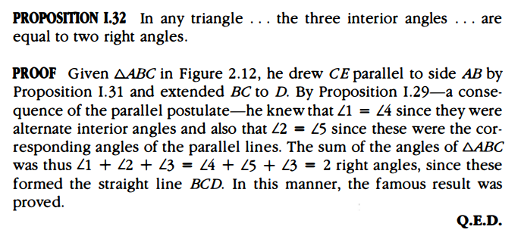

**Additional Suggested Reading**: Book I, *Elements*

**Assignment:** Homework Problem 14, 16, 17, Prove Prop I.41 (cannot use the algebraic formula for area of a triangle) (EC)